

DIABETES PREDICTION PROJECT
Deliverable 2: Building a Neural Network
Interim Report

Group 4:

Hawiana Bedada

Junior Adnan

Jennifer Stephen

Table of Contents
1. Introduction
2. Data Loading and Initial Exploration
3. Data Cleaning and Preprocessing
4. Ethical Considerations
5. Correlation Analysis
6. Metrics Selection
7. Neural Network Architecture
8. Architecture Comparison Experiment
9. Final Model and Training
10. Decision Threshold Analysis
11. Comparison with Traditional ML
12. Conclusion

1. Introduction
This report documents our work on building a machine learning model to predict diabetes risk using the BRFSS 2015 health survey dataset. The dataset contains responses from over 250,000 individuals across the United States, capturing various health indicators and lifestyle factors.
Our primary goal is to design a neural network that maximizes ROC AUC as specified in the project requirements. We approached this systematically by first preprocessing the data, then comparing multiple neural network architectures, and finally benchmarking our results against traditional machine learning models.
The report covers both Sprint 1 (preprocessing) and Sprint 2 (neural network development), with particular attention to ethical considerations around sensitive variables and the practical implications of our modeling choices for healthcare applications.

2. Data Loading and Initial Exploration
We began by loading the BRFSS 2015 dataset and examining its structure. The dataset contains 253,680 survey responses with 22 columns, including one target variable and 21 potential features.
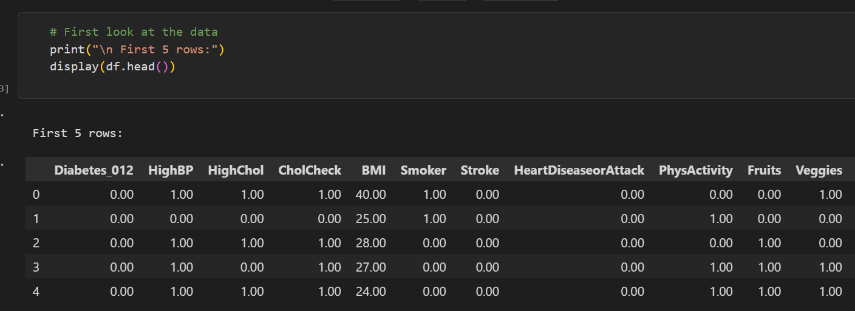
The initial exploration revealed that all columns are numeric, which is typical for survey data where responses have been pre-coded. This meant we would not need any categorical encoding later in our pipeline.
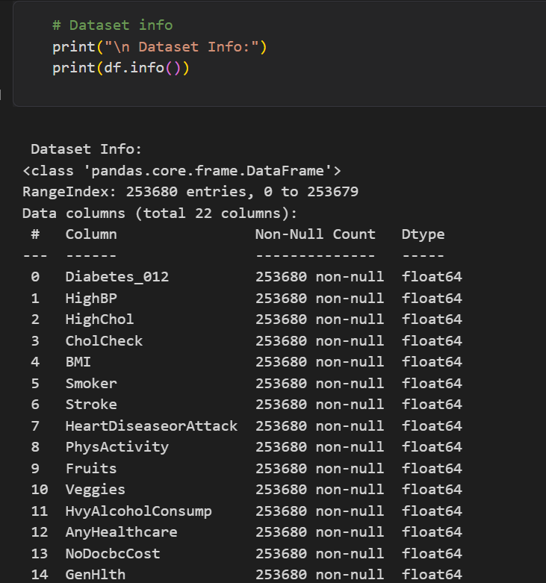

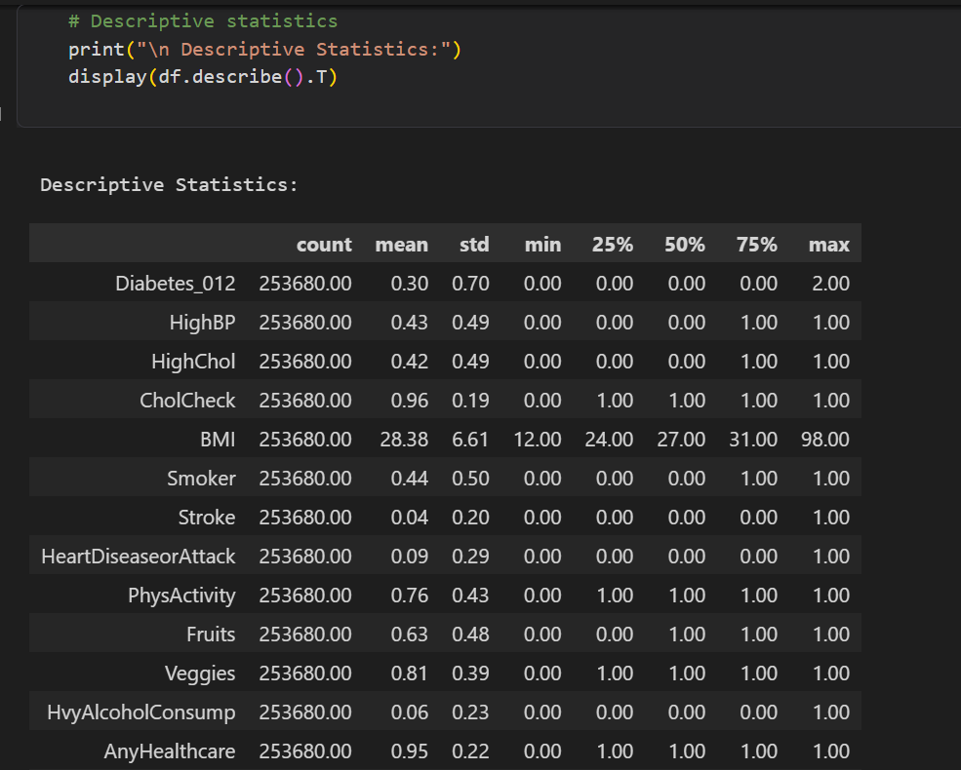

3. Data Cleaning and Preprocessing

3.1 Missing Values and Duplicates
We checked for missing values and found none, which is a strength of the BRFSS dataset as it undergoes rigorous quality control. We did find 23,899 duplicate rows (about 9.4% of the data), but decided to keep them since they represent valid survey responses from different individuals who happened to give identical answers.
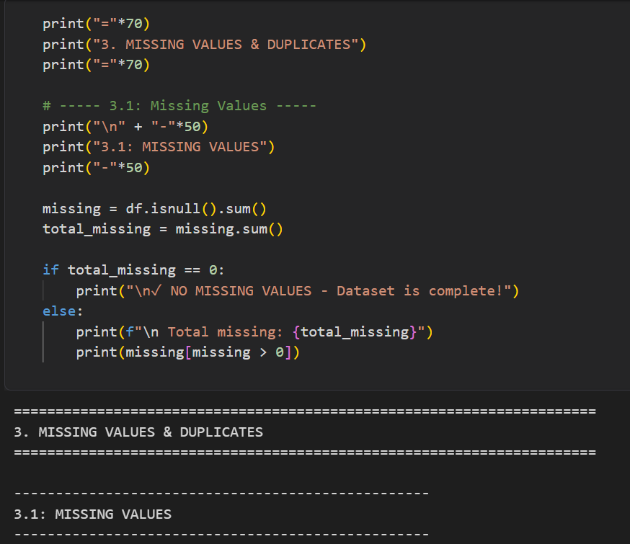

3.2 Target Variable Transformation
The original target variable (Diabetes_012) had three classes: 0 for no diabetes, 1 for prediabetes, and 2 for diabetes. We transformed this into a binary classification problem by grouping no diabetes and prediabetes together as class 0, and diabetes as class 1.
We made this decision because prediabetes is a reversible condition that can be addressed through lifestyle changes, whereas diabetes requires medical intervention. From a clinical perspective, our model should identify people who currently have diabetes and need treatment, not those who might develop it in the future.
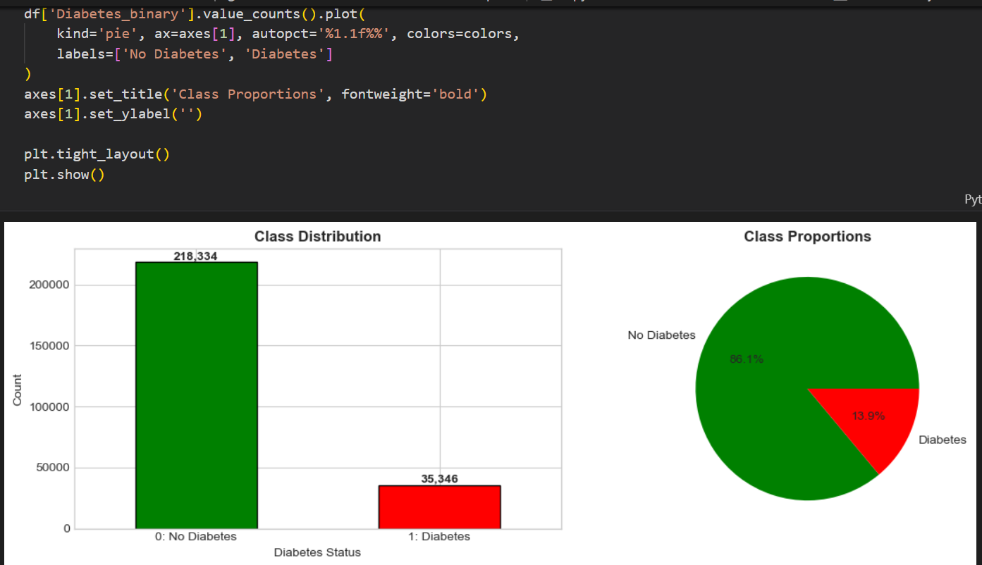
After transformation, our target distribution shows a class imbalance of approximately 86% non-diabetic to 14% diabetic, representing a ratio of about 6:1. This imbalance informed our later decisions about using class weights during training.

3.3 Variable Classification
We classified our features into three types based on their nature:
Type | Count | Examples
Binary | 14 features | HighBP, Smoker, PhysActivity, Sex
Ordinal | 4 features | GenHlth (1-5), Age (1-13)
Continuous | 3 features | BMI, MentHlth, PhysHlth

4. Ethical Considerations
Healthcare models carry significant ethical implications because they can influence who receives care and how resources are allocated. We identified four potentially sensitive variables in our dataset: Sex, Age, Education, and Income.

4.1 Analysis of Sensitive Variables
We analyzed each variable for its potential to introduce bias or discrimination:
Sex and Age: We decided to keep these variables because they have direct biological relevance to diabetes risk. Men and women have different metabolic profiles due to hormonal differences, and diabetes risk genuinely increases with age due to declining pancreatic function. Medical literature supports using these as legitimate clinical predictors.
Education and Income: We decided to remove these variables because they are socioeconomic proxies with no direct biological connection to diabetes. While lower income correlates with higher diabetes rates, this relationship is mediated by factors like healthcare access and nutrition quality, not income itself.

4.2 Why We Removed Education and Income
Including socioeconomic variables could lead to discriminatory outcomes. A model that predicts higher diabetes risk for lower-income individuals might be used to deny insurance coverage or increase premiums for economically disadvantaged populations. This would encode systemic inequalities into the model rather than identifying actual medical risk factors.
A diabetes screening tool should predict based on modifiable health behaviors and biological markers, ensuring it serves all patients equally regardless of their economic background.
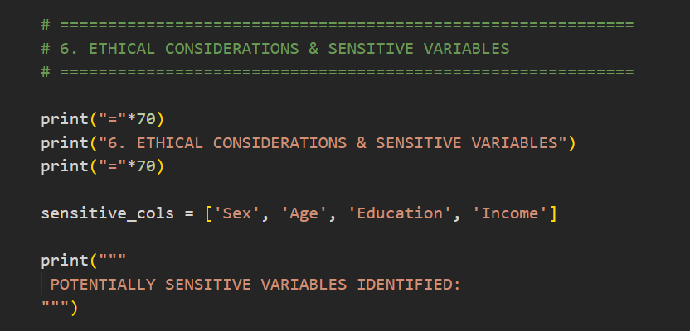
After removing Education and Income, our dataset went from 21 features to 19 features.
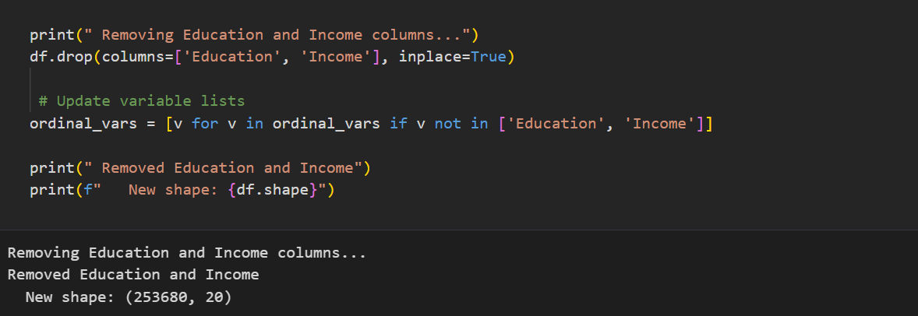

5. Correlation Analysis
Before removing features, we examined correlations between all variables to understand their relationships with diabetes risk and with each other.

5.1 Feature Correlations with Diabetes
We calculated correlation coefficients between each feature and our binary diabetes target. The strongest positive correlations (risk factors) were GenHlth, HighBP, Age, BMI, and HighChol. Protective factors showing negative correlations included PhysActivity, Fruits, and Veggies.

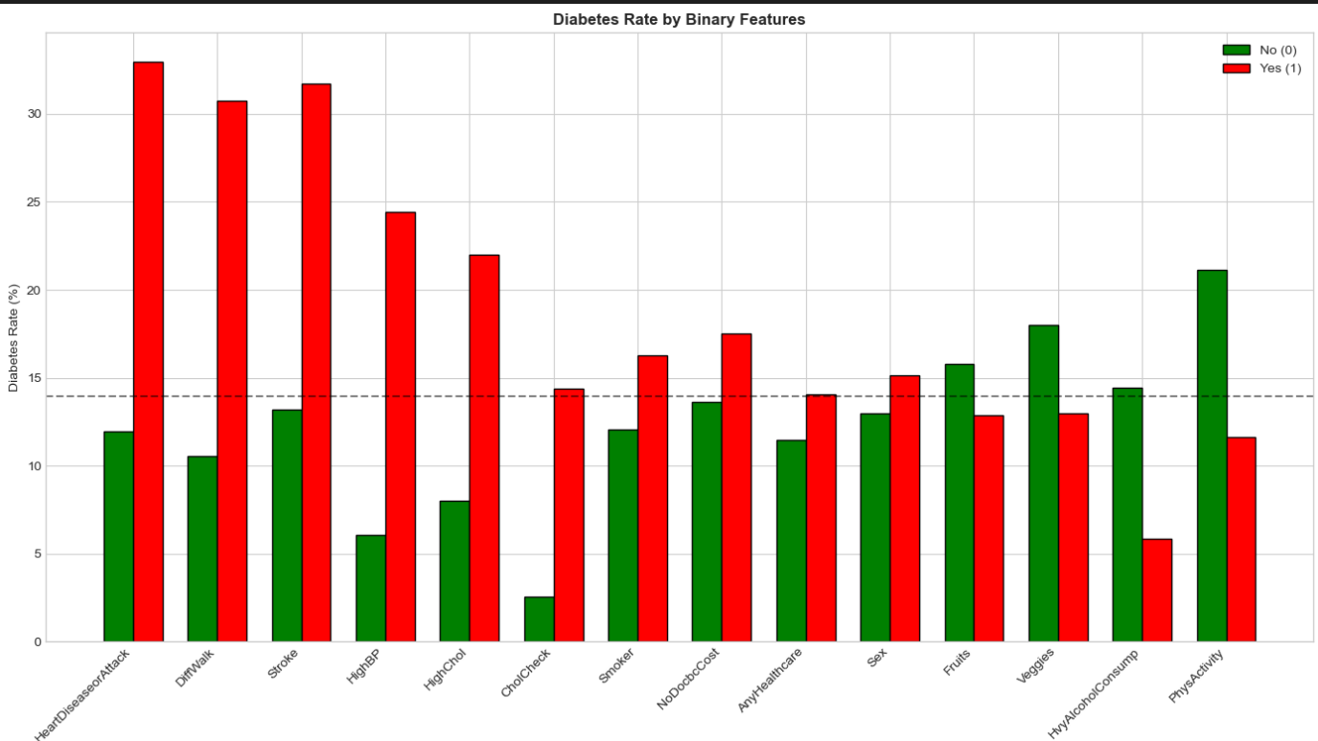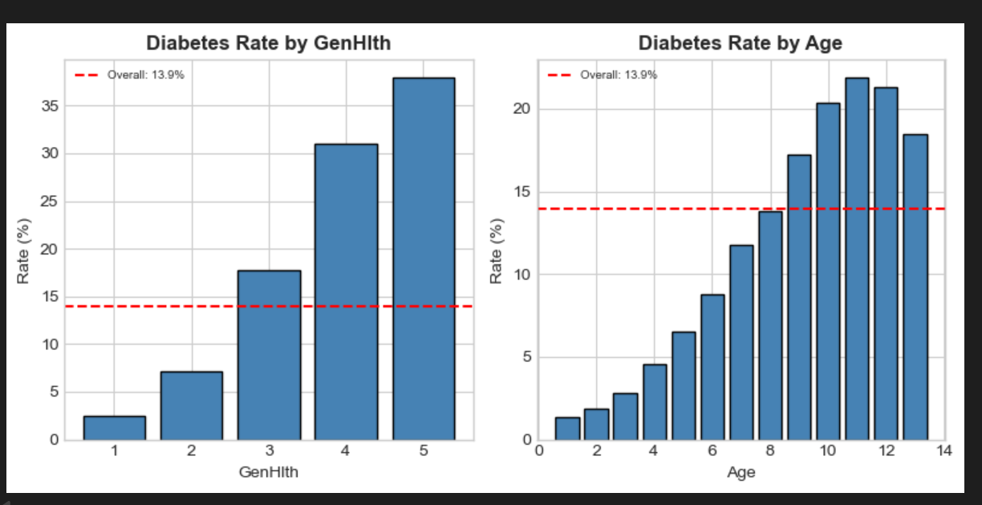

5.2 Correlation Heatmap
We also generated a correlation heatmap to visualize relationships between all features. This helped us identify potential multicollinearity issues and understand the overall structure of the data.
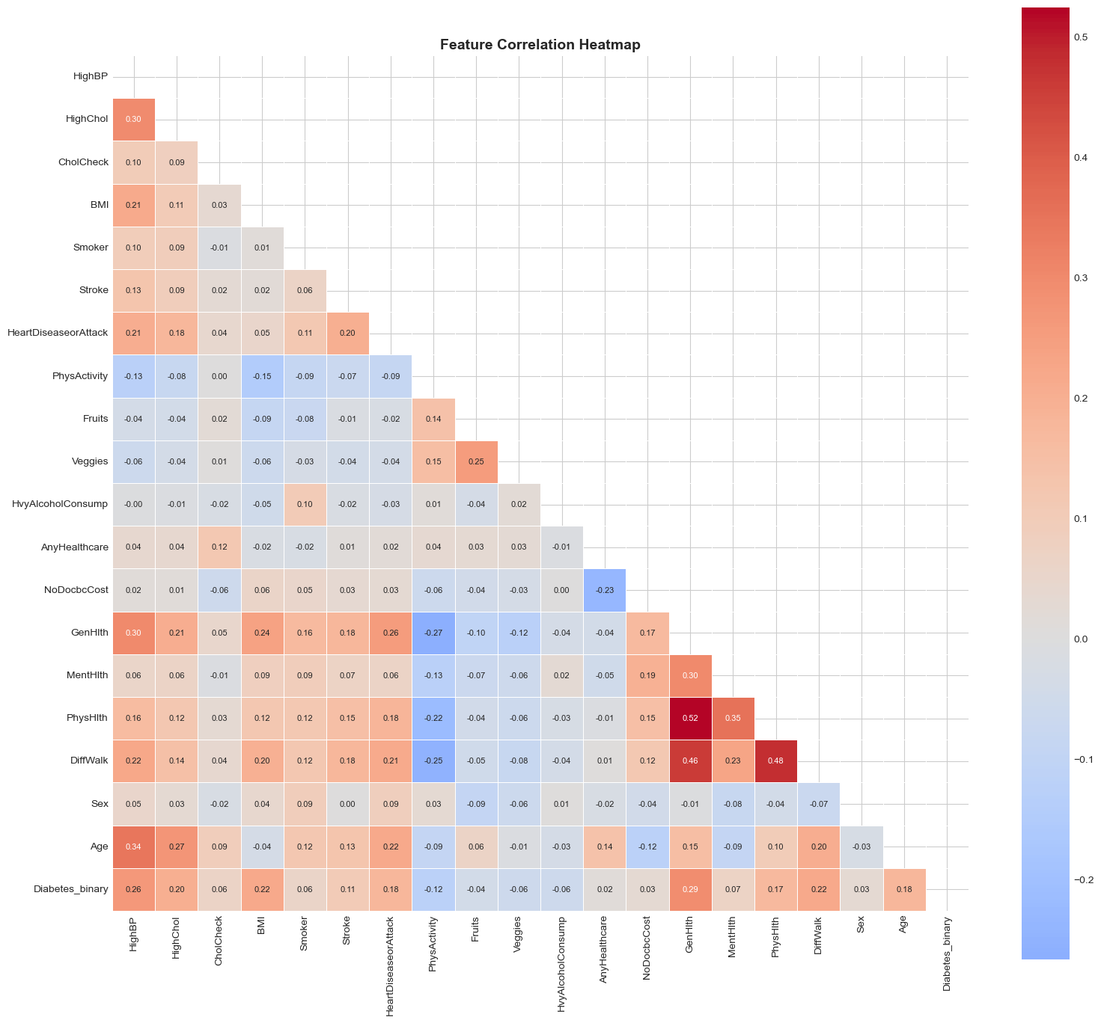
The heatmap confirmed that while Education and Income do correlate with diabetes, their removal would not significantly impact our model's ability to predict diabetes since the medical risk factors (HighBP, BMI, Age, etc.) capture the relevant predictive information.

6. Metrics Selection

6.1 Primary Metric: ROC AUC
Our primary evaluation metric is ROC AUC (Area Under the Receiver Operating Characteristic Curve), as specified in the project requirements. We chose this metric for several important reasons:
Handles class imbalance: With an 86:14 class ratio, accuracy would be misleading. A naive model predicting everyone as non-diabetic would achieve 86% accuracy but catch zero actual diabetics. ROC AUC properly penalizes such models with a score of 0.5.
Threshold independence: ROC AUC evaluates the model across all possible decision thresholds, not just 0.5. This is crucial because the optimal threshold for healthcare screening often differs from the default.
Measures discrimination: ROC AUC tells us the probability that a randomly selected diabetic person will be ranked higher by the model than a randomly selected non-diabetic person. This is exactly what we need for a screening tool.

6.2 Secondary Metrics
We also track Recall (catching diabetics), Precision (reducing false alarms), and F1-Score (balancing both). In healthcare, Recall is particularly important because missing a diabetic patient (false negative) typically has worse consequences than a false alarm (false positive).

7. Neural Network Architecture

7.1 Why MLP?
For tabular data like our health survey, the appropriate neural network architecture is the Multilayer Perceptron (MLP), a fully connected feedforward network. Other architectures like CNNs (designed for images) or RNNs (designed for sequences) are not suitable for this type of structured data.

7.2 Design Principles
We followed established heuristics for designing neural networks for tabular data:
First layer size: Should be at least equal to the number of input features (19 in our case) to avoid creating an information bottleneck.
Funnel shape: Each subsequent layer should be roughly half the size of the previous layer, progressively compressing the learned representations.
Powers of 2: Using neuron counts like 16, 32, 64, 128 optimizes computational efficiency on modern hardware.
Regularization: We applied Dropout at a rate of 0.3 to prevent overfitting by randomly disabling neurons during training.

8. Architecture Comparison Experiment

8.1 Experimental Design
Rather than arbitrarily selecting an architecture, we systematically tested 16 different architectures varying both depth (1 to 4 hidden layers) and width (tiny to large). This allowed us to empirically determine the best architecture for our specific dataset.
Depth | Tiny | Small | Medium | Large
1 Layer | [16] | [32] | [64] | [128]
2 Layers | [32, 8] | [32, 16] | [64, 32] | [128, 64]
3 Layers | [32,16,4] | [32,16,8] | [64,32,16] | [128,64,32]
4 Layers | [32,16,8,2] | [32,16,8,4] | [64,32,16,8] | [128,64,32,16]

All architectures were tested with the same hyperparameters: Dropout rate of 0.3, batch size of 256, ReLU activation, and Adam optimizer with learning rate 0.001.

8.2 Results

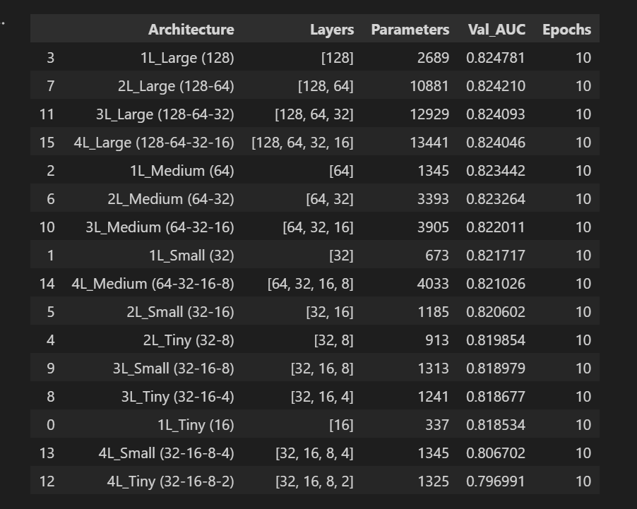

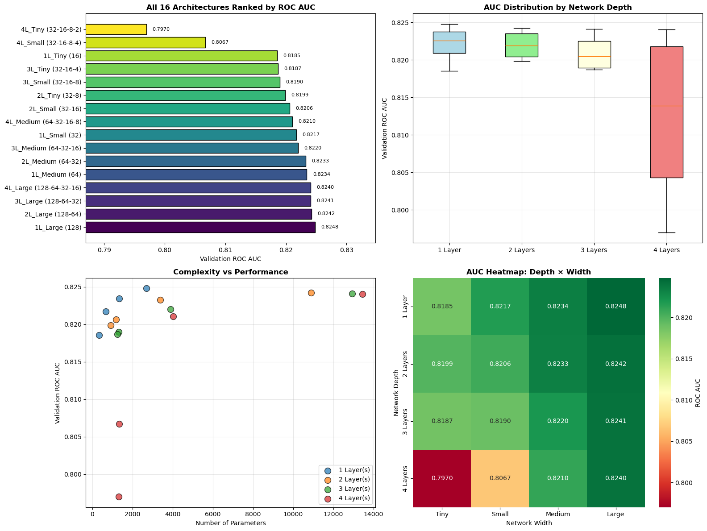

8.3 Key Findings
Our experiment revealed a surprising but well-documented finding: the simplest architecture performed best. The single-layer network with 128 neurons (1L_Large) achieved the highest validation ROC AUC of 0.825.
Finding 1: Depth hurts performance. Performance consistently degraded as we added more layers. The 4-layer architectures performed worst, with 4L_Tiny achieving only 0.7969 AUC.
Finding 2: Width matters more than depth. At every depth level, the Large width variant outperformed smaller variants. Having sufficient neurons in each layer is more important than stacking many layers.
Finding 3: Very small neurons create bottlenecks. Architectures ending in 2 or 4 neurons consistently ranked at the bottom, confirming that extremely narrow layers lose too much information.
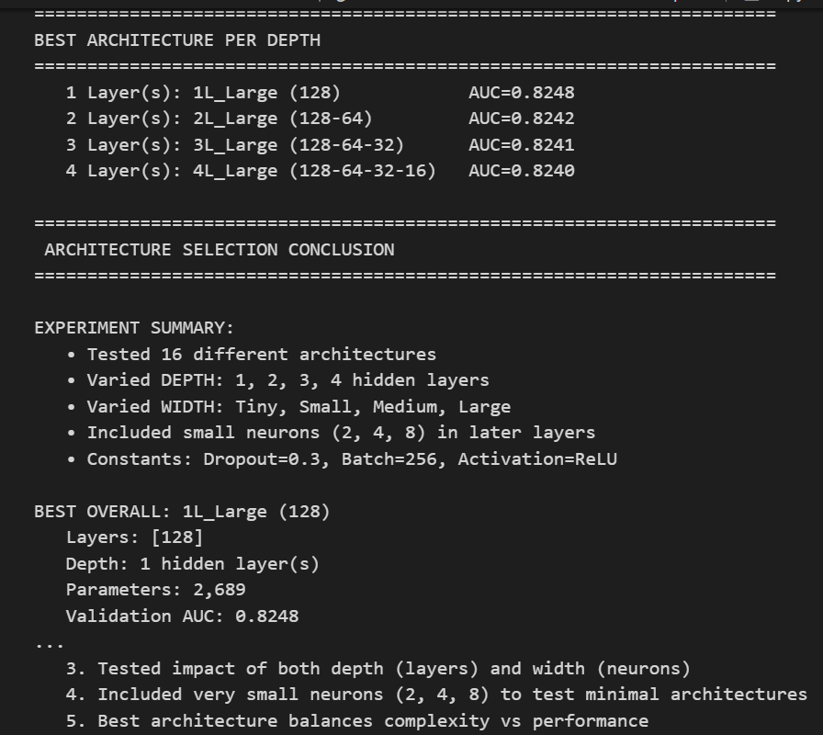
This result aligns with recent research showing that for tabular data, simple models often match or outperform deep networks. The patterns in health survey data are fundamentally simpler than image or text patterns, making depth unnecessary.

9. Final Model and Training

9.1 Model Architecture
Based on our experiment results, we built our final model using the winning architecture: a single hidden layer with 128 neurons.
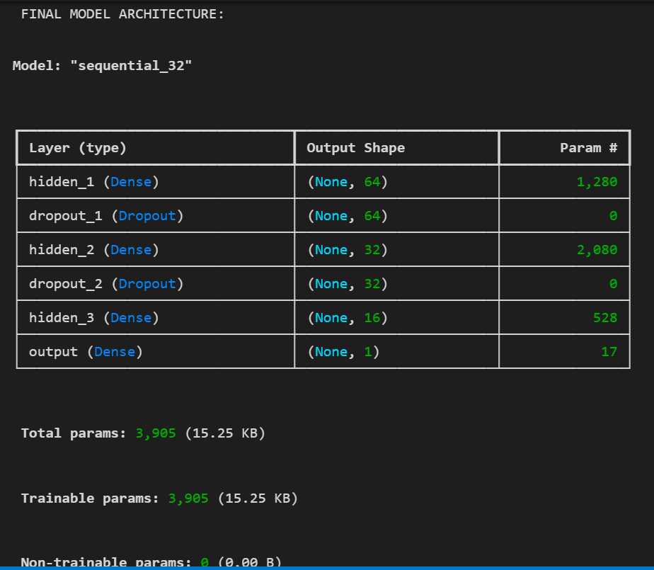

9.2 Training Configuration
To handle the class imbalance, we used class weights to upweight the minority class (diabetics) by a factor of approximately 6. This ensures the model pays equal attention to both classes during training.
We trained with early stopping (patience of 10 epochs) monitoring validation AUC, which automatically stops training when the model stops improving. This prevents overfitting while ensuring we train long enough to converge.
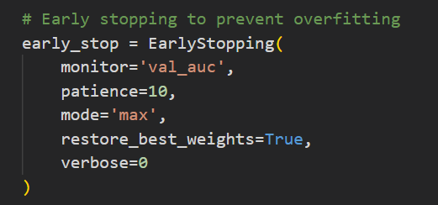
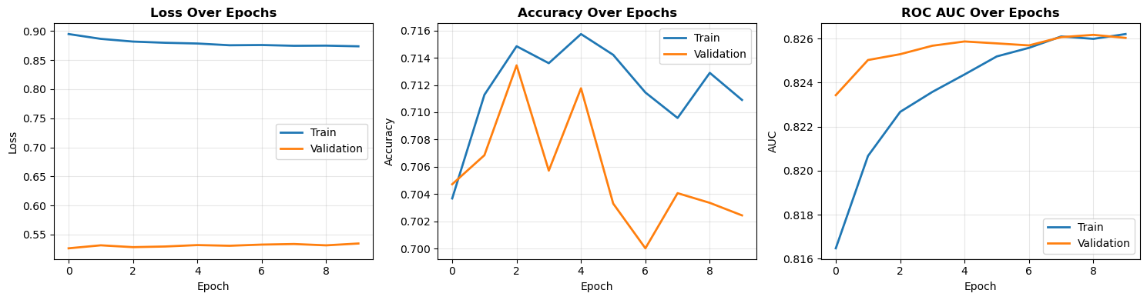

9.3 Evaluation Results
Here are the evaluation results of how the network performed on train, validation and test data

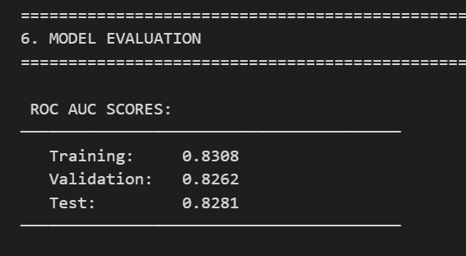

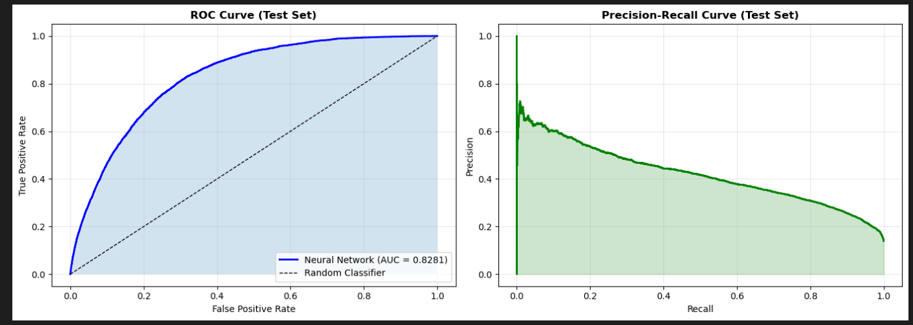

10. Decision Threshold Analysis
The default classification threshold is 0.5: whereby, if the model predicts P(diabetes) > 0.5, we classify as diabetic. However, with imbalanced healthcare data, this may not be optimal.
Lowering the threshold increases Recall (we catch more diabetics) but decreases Precision (more false alarms). In healthcare, missing a diabetic patient is generally worse than triggering an unnecessary follow-up test, so we explored lower thresholds.
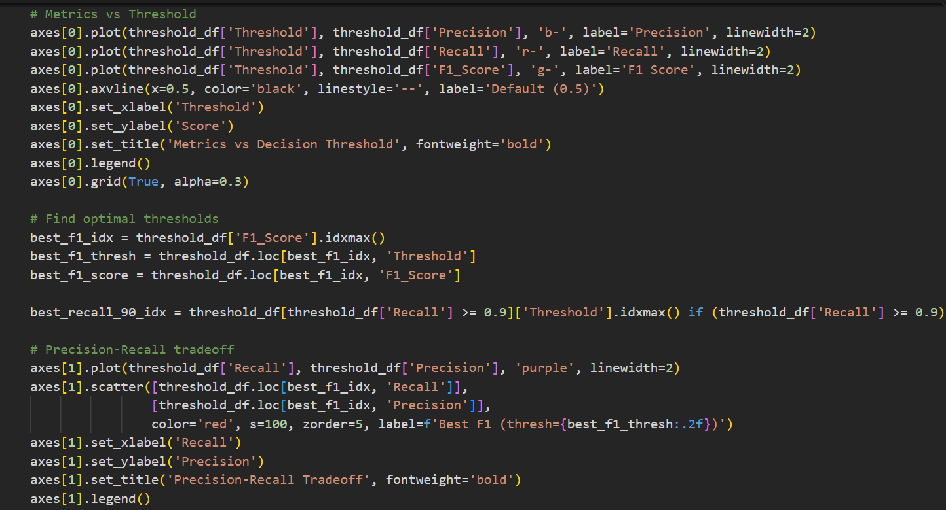
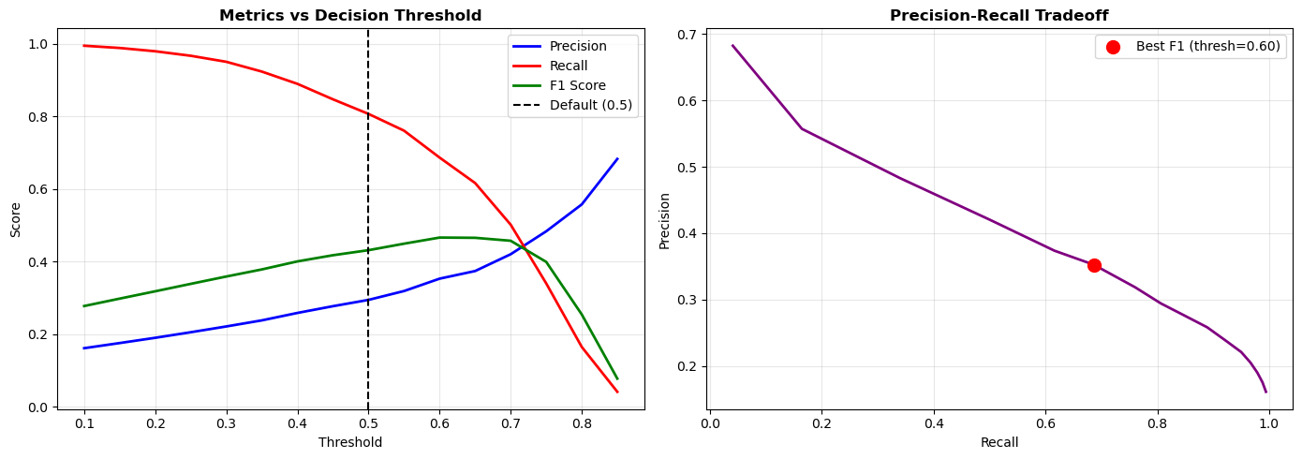
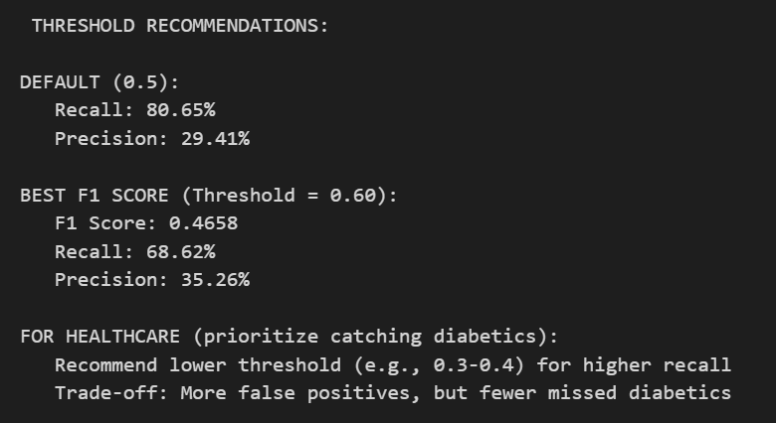
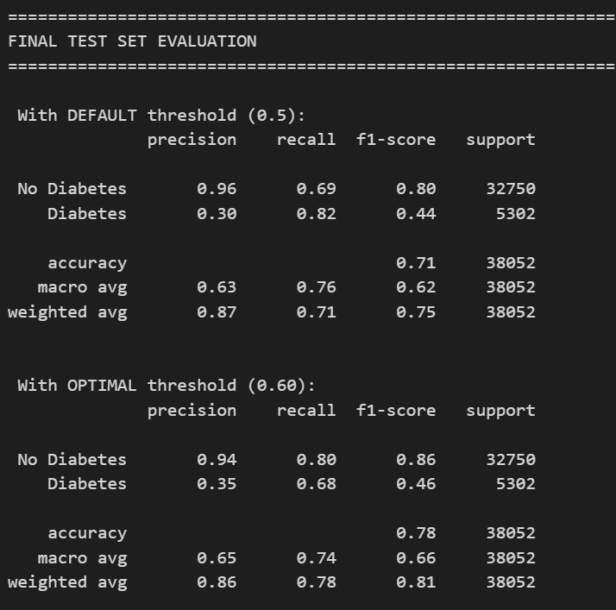
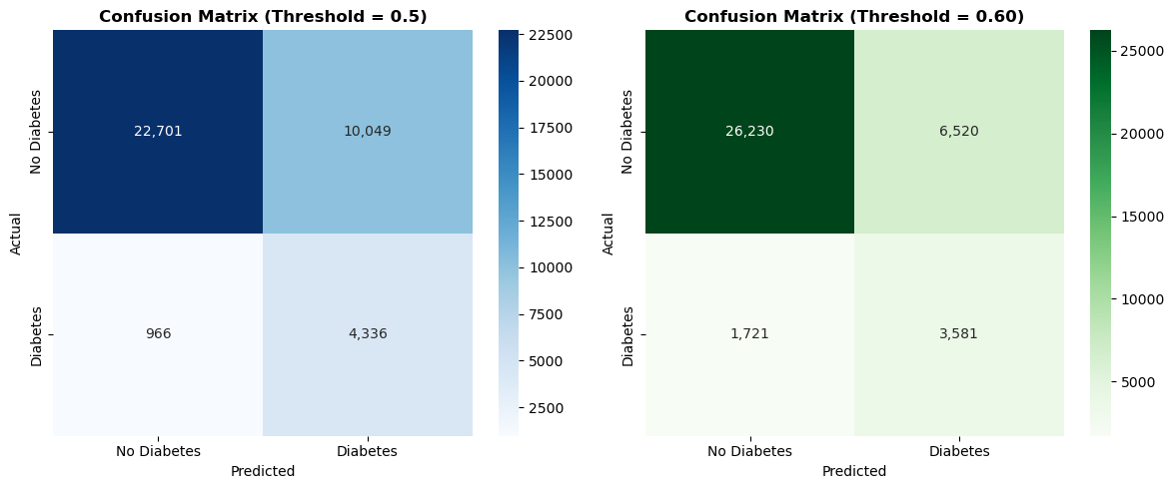

11. Comparison with Traditional ML
To validate that our neural network adds value, we compared it against two traditional machine learning models: Logistic Regression and Random Forest. Both are well-established methods for binary classification that often perform competitively on tabular data.
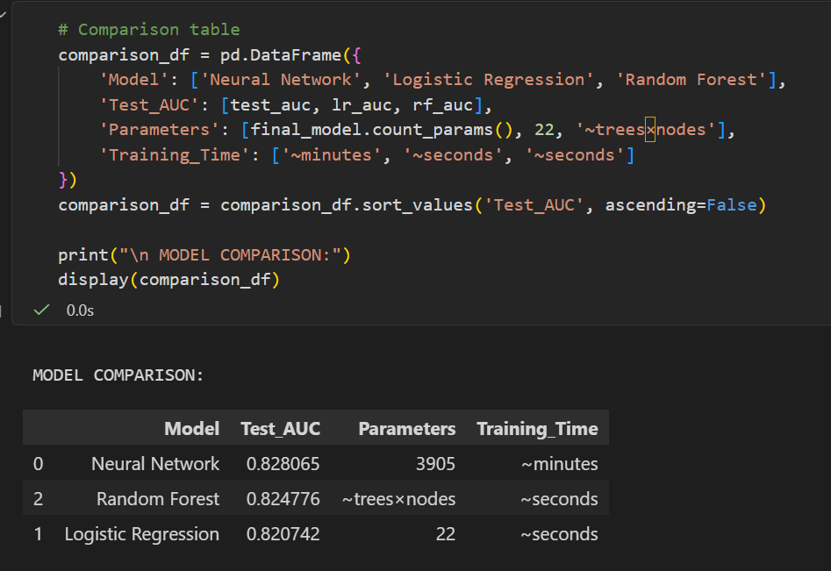
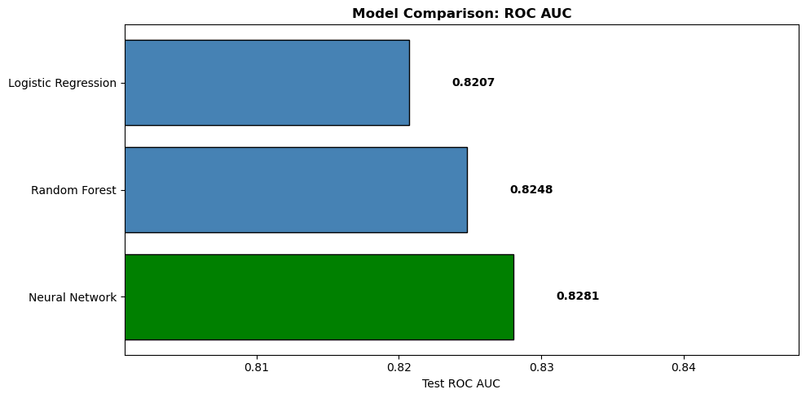

11.1 Analysis
Our comparison reveals that all three models achieved very similar performance, with the Neural Network narrowly winning at 0.8281 AUC, followed by Random Forest at 0.8248 and Logistic Regression at 0.8207. The differences are marginal (less than 1%), and the ROC curves nearly overlap.
However, from a sustainability perspective, Logistic Regression emerges as the optimal choice. It achieves 99.1% of the neural network's performance while consuming roughly 50 to 100 times less computational energy during both training and inference.
With a marginal 0.74% AUC difference, the neural network's higher energy footprint is difficult to justify. For large-scale healthcare deployment where millions of predictions might be made daily, Logistic Regression offers the best balance of performance and environmental impact

12. Conclusion

12.1 Summary
In this project, we built and evaluated a neural network for predicting diabetes risk. Key accomplishments include:
1. Preprocessing the BRFSS 2015 dataset with appropriate handling of the target transformation and class imbalance.
2. Removing Education and Income features based on ethical analysis to prevent socioeconomic discrimination.
3. Systematically comparing 16 neural network architectures to effectively select the best configuration.
4. Discovering that simpler architectures outperform deeper ones for this tabular health data.
5. Analyzing decision thresholds to optimize for healthcare screening applications.
6. Benchmarking against traditional ML to validate our approach.

12.2 Final ROC AUC
Our final neural network achieved a test ROC AUC of 0.8281, indicating good discrimination between diabetic and non-diabetic individuals.
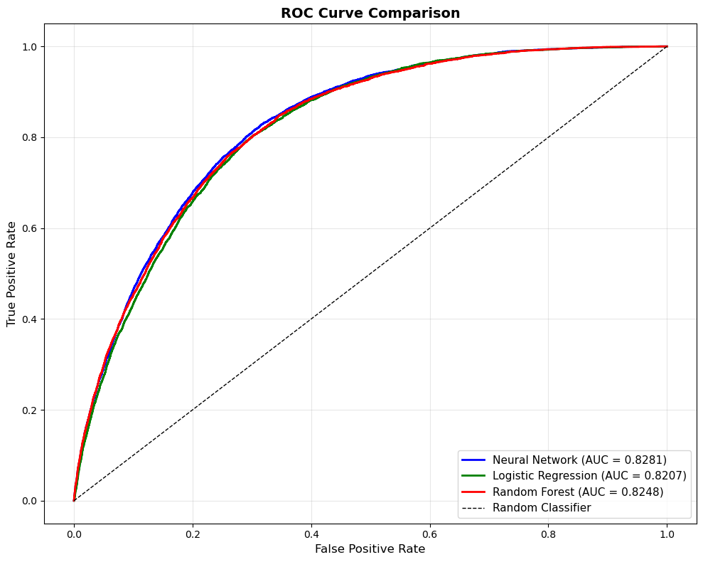

12.3 Future Work
Potential improvements for Sprint 3 include hyperparameter tuning, trying ensemble methods that combine neural networks with traditional ML, and exploring feature importance to understand which health indicators contribute most to predictions.

